The Coversheet

Student Name  (unless anonymised) | N/A as your assessment is anonymous
Student Number
(as shown on student ID card):
Word Count / Pages / Duration / Other Limits:
Attempt Number:
Date of Submission:

I have read and understood the Academic Misconduct statement. | Tick to confirm ☐
I have read and understood the Generative Artificial Intelligence use statement. | Tick to confirm ☐
I am satisfied that I have achieved the Learning Outcomes of this assignment  (please check the Assignment Brief if you are unsure) | ​​​ Met ☐

Self-Assessment – If there are particular aspects of your assignment on which you would like feedback, please indicate below.
Optional for students
Suggested prompt questions-
How have you developed or progressed your learning in this work?
What do you feel is the strongest part of this submission?
What feedback would you give yourself?
What part(s) of this assignment are you still unsure about?

Assessor’s Feedback (may be delivered in line with the submission)

Were the learning outcomes met? | Yes ☐ If not, what was not met:
Assessor’s response to the student’s submission, request for feedback and / or self-assessment (feedback):

What specific actions should the student undertake to progress their learning? (feedforward):

Please take this and other feedback to your next academic tutorial to plan your future work.

A DATA-DRIVEN ASSESSMENT OF HOSPITAL UTILISATION, CAPACITY EFFICIENCY, AND PATIENT FLOW DYNAMICS USING ENCOUNTER-LEVEL HEALTHCARE DATA

Executive Summary
This portfolio involves an exploratory data analysis (EDA) of the healthcare encounter-level data to facilitate the process of planning hospital capacity, service efficiency, and optimise patient flow. It analyses trends in utilisation with time, lines of service, lines of diagnosis and patient pathways to come up with the operational insights. Findings depict that there is a long-run trend of increasing admissions with sporadic demand bursts whereby admissions, ED visits, and bed-days soar drastically. Such abnormalities indicate that capacity pressure is frequently instigated by fluctuation in the length of stay (LOS) and contact intensity rather than elevated volumes. The majority of the consumption in bed-day is in inpatient encounters even though they constitute a smaller portion of the entire encounters. At diagnosis level, the findings suggest that stage of problem/symptom/categories have very skewed LOS with extreme upper-tail stays occupying disproportionately the bed, whereas routine/preventive care are very short and predictable. Seasonality is diagnosis specific and not on a system wide basis. Recurring patterns of patient journey (readmission after 7-30 days and multi-complicated transfers) demonstrate a need in continuity-of-care.

Table of Contents
1. Introduction 4
1.1 Objectives 5
2. Dataset Characteristics 5
3. Methodology 6
4. Results and Analysis 8
4.1 Utilisation Stability and Demand Volatility 8
4.2 Capacity Efficiency Across Services and Diagnoses 12
4.3 Seasonal Sensitivity of Clinical Demand 15
4.4 Patient Flow and Repeat Utilisation Dynamics 17
5. Discussion and Insights 19
6. Limitations 21
7. Ethical Considerations 22
8. Conclusion 22
9. References 24

1. Introduction
The hospitals are increasingly working in extremely constrained environments that are characterised by the growing patient demand, staffing issues and the financial constraints to provide high quality care in a cost-effective manner. Operational efficiency in the use of inpatient bed, emergency department (ED) services and outpatient pathways has thus become a focal issue in the process of healthcare operations and policy. The recent research points to the fact that any length of stay (LOS), repeated patient contacts, and unexpected changes in demand may pose a serious threat to the system resilience and patient outcomes (Lee et al., 2024; Turbow et al., 2024). At this, the exploratory data analysis (EDA) can be taken as a critical background to comprehend the utilisation of healthcare resources in the long run and within the service lines. Instead of being limited to predictive modelling, EDA allows analysts to find structural patterns, variability, and anomalies in past encounter-level data that are needed to make informed capacity planning and service redesign (Seo et al., 2024). Moreover, the growing accessibility to large-scale healthcare data has highlighted the need to adopt more analytical methods to go beyond average metrics to measure variability, efficiency, and patient flow stability (Maynou et al., 2023). This portfolio uses a systematic EDA system to approach encounter-level healthcare data to assess the utilisation dynamics, capacity efficiency and patient journey behaviour of a hospital network. The discussion is based on an operational view with specific focus on the contribution patterns of LOS, the bed-day consumption, seasonal sensitivity and repeat utilisation to the system-level pressure. Previous studies have found that predictable but uneven utilisation over time, especially in emergency and inpatient care, may be realised by seasonal factors, environmental circumstances, and demand profile specific to a service (PoshtMashhadi et al., 2025).

1.1 Objectives
The main goals of such analysis are four. First, it will evaluate the changes in the monthly and quarterly admissions, ED activity, bed-day utilisation and LOS, to determine variability and abnormal demand trends. Second, it aims at establishing what service lines and categories of diagnosis are most consuming capacity and whether these consumptions are indicative of long-term inefficiency or capacity growth. Third, it examines seasonal sensitivity to diagnosis to determine risk of utilisation by time. Lastly, it analyses patient journey dynamics such as repeat and short interval returns to provide actionable insights to help with capacity planning, discharge optimisation, and specific follow-up plans. In this way, the study will show how evidence-based decision-making in the contemporary healthcare system can be supported with the help of the exploratory analytics.

2. Dataset Characteristics
The synthea analysis is performed on the encounter-level healthcare data created with the help of the Synthea synthetic data framework. Each record is one encounter with a patient, and therefore it is possible to analyse multiple interactions of the same individual longitudinally. The structure allows analysing the patterns of utilisation, pressure on capacity, and patient flow across time and service lines without the ethical and legal limitations of actual patient information (Walonoski et al., 2018). The data set includes time based variables, which include the beginning and ending time of encounter, categorical variables, which define encounter type (e.g. inpatient, emergency, ambulatory) and clinical variables, including primary diagnosis and count of conditions. Operational measures are length of stay in number of days (LOS_DAYS) and encounter cost. Heterogeneity exists in the LOS values since the presence of several types of encounters in one dataset implies that outpatient and wellness visits are very brief in comparison with inpatient stays. Such heterogeneity requires cautious preprocessing and significant statistical manipulation to prevent the distortion of aggregate measures as illustrated in the recent literature on healthcare analytics (Lee et al., 2024). There are certain steps that were taken in data preparation in order to guarantee analytical validity. To allow temporal aggregation and sequencing, first, all date and time fields have been transformed into standard formats of a datetime. The invalid or negative values, LOS, were discarded in order to maintain data integrity. All cases of missing values in the condition count and description of diagnosis fields were handled through conservative imputation strategies which ensured that records were not lost to exploit in the utilisation analysis without injecting artificial clinical assumptions. Derived temporal features such as month and quarter were formed to ease the multi-scale time analysis. The data was not reorganized into monthly aggregation only, but also facilitated both monthly and quarterly presentation. This two-sided method allows the opportunity to examine short-term changes of fluctuations in a detailed way and more consistent evaluations of trends in utilisation. Multi-resolution temporal analysis of this type is becoming a common recommendation in healthcare operations research to trade off between responsiveness and interpretability (Seo et al., 2024). In general, these preparation measures were able to guarantee that the data was analytically and reproducibly consistent as well as able to support further exploratory analysis of the dynamics of patient flow and hospital utilisation.

3. Methodology
The framework of the analysis designed in the context of this study will examine hospital utilisation with the help of the integrative perspective of stability, efficiency, seasonality, and patient flow. The framework instead of focusing on volume based measures solely, previews vigorous statistical measurements and pathway based analyses and thus represents the working realities of healthcare provision. In order to measure the dynamics of utilisation the methodology uses both monthly and quarterly temporal resolutions. Monthly aggregation is also used to pick short-term changes in admissions, emergency department (ED) visits, bed-days, and average length of stay (LOS), which is tied directly to the business requirements of operational monitoring. Quarterly aggregation offers a complementary macro-view, which breathes out short-term noise and allows a better evaluation of the stability and variability of utilisation in the long term. This methodology is in line with the best practice of healthcare demand analysis, in which the multi-scale temporal aspects promote better interpretation and accuracy in planning (Seo et al., 2024). The framework is anchored on the use of strong statistical measures. The median LOS and interquartile range (IQR) are given more importance than the mean values to reduce sensitivity to the extreme observations caused by heterogeneous types of encounters. Variability and volatility are also measured in terms of dispersion measure, which can enable one to identify the intervals in which demand is fluctuating but not just increasing. This type of techniques has been shown to provide more credible results on operational risk than mere averages (Maynou et al., 2023). Capacity efficiency is measured by determining the ratio of total bed-days to the volume of encounters thus creating service level efficiency indices indicating high volume and high intensity utilisation. Diagnosis-level analysis takes this view a step further to look at LOS distributions and percentile-based intensity measures and allows one to identify clinical categories that impose disproportionate strain on capacity. Normalised month-level measures and variance are analysed to measure seasonal sensitivity, which allows diagnosis groups to be compared regardless of their baseline levels of utilisation. This normalisation is critical in identifying the true effects of seasonality which differ significantly across the clinical fields (PoshtMashhadi et al., 2025). Lastly, patient journey analysis takes the spotlight off individual interactions, but at the system level. To describe repeated utilisation patterns, the time-to-next-encounter measures, and the care sequence measures are used instead of binary readmission measures. This more general view is consistent with modern evidence that repeated healthcare suggests not failure of isolated discharge in inpatient but continuity-of-care systemic issues (Turbow et al., 2024). Taken together, such elements of analysis form a unified system of producing actionable information to aid in capacity planning, discharge optimisation, and focused follow-ups.

4. Results and Analysis

4.1 Utilisation Stability and Demand Volatility
This part examines time trends of hospital utilisation focusing on demand stability, variability, and extreme fluctuations. Monthly and quarter aggregations are used to reflect short term variations as well as long term structural variations in admissions, ED visits, bed-day utilisation and LOS. Cumulatively, these views make knowledge on operational risk and capacity pressure in the long term.
Quarterly Utilisation Trends
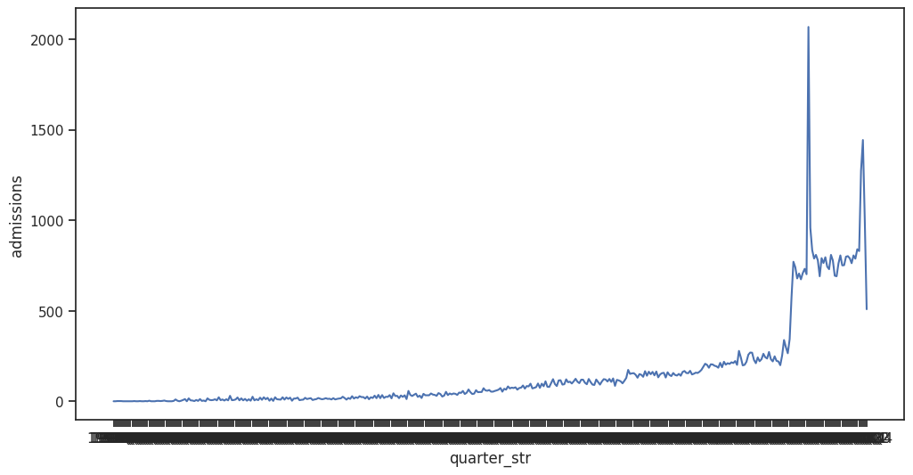
The quarterly admissions show a visible long term rising trend with fairly lower and constant volumes in the preceding years and a sharp increase in the following years. This trend indicates an upward structural demand shift and not short term sporadic demand shifts. It is interesting to note that some of the extreme peaks are observed in the latest quarters where the admissions have skyrocketed in comparison to the previous baselines. These spikes denote the intermittent demand peaks that will most probably cause acute strain on the hospital capacity.
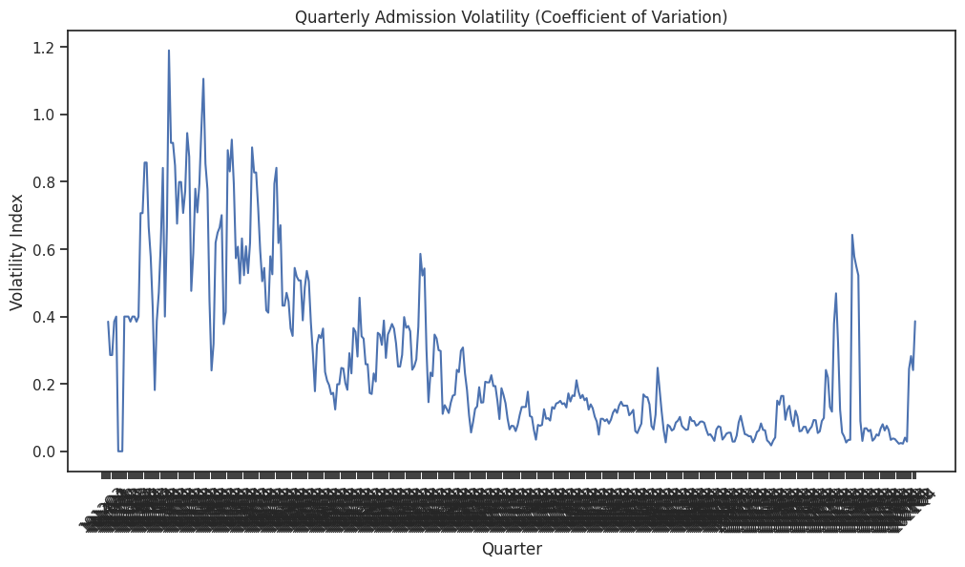
To further pinpoint this trend, the volatility analysis, which is measured using the rolling coefficient of variation, provides further background to the trend. The high volatility can be observed during the early periods, representing a state of instability during the periods when there is a general low level of admission volumes. As the system gets matured and used more, volatility tends to reduce indicating increased relative stability. However, the reappearance of volatility spikes later in time is linked to both the sudden increase in admissions, which highlights the operational risk during the high-demand period. This trend can be explained by the fact that antecedent evidence indicates that healthcare systems can be relatively robust during the period of moderate demand but start to become weaker during the conditions of the rapid rise of the demand (Seo et al., 2024).

Monthly Fluctuations and Multi-Metric Comparison
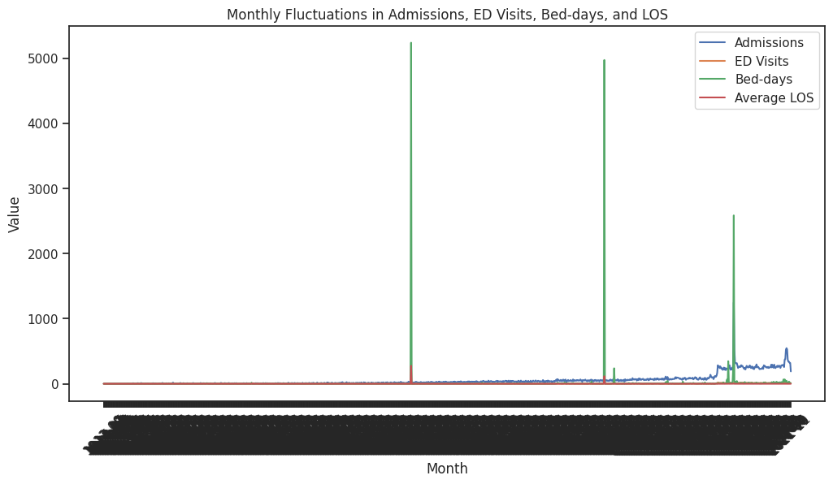
Monthly analysis will allow one to directly compare admissions, ED visits, bed-days, and average LOS, which are needed to monitor operations. Admissions and ED visits have quite similar temporal patterns, which means that the general development of demand is strongly related to the usage of emergency services. Bed-days, on the other hand, show volatile peaks in the months of the year which are not necessarily in proportion to the number of admissions. These bed-day extremes indicate some timeframes when LOS was significantly higher, and it could be because there was an increase in the complexity of cases, or discharge bottlenecks, or reduced downstream capability. Average LOS is also relatively low during most months as short ambulatory and outpatient encounters of the dataset constitute high proportion. Nevertheless, average LOS increases are evident in several months, and they are associated with the extreme bed-day spikes. This inconsistency in terms of admission volume and LOS shows that the pressure on capacity is not caused by patient numbers only but also by the variation in care intensity and throughput efficiency. This has been observed to be mirrored in empirical studies, as LOS variability is also one of the major determinants of bed occupancy and congestion (Lee et al., 2024).
Identification of Anomalies and Outliers
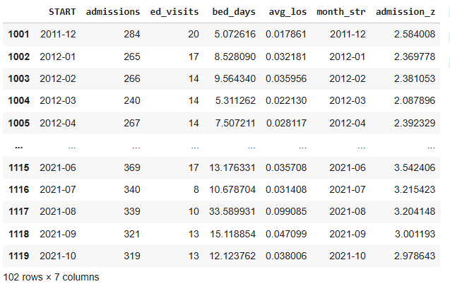
Standardised admission scores (z-scores) draw attention to few months where the values are higher than the traditional values of statistical outliers. These abnormal periods are associated with the highest peaks of admissions noted in the monthly time series. Notably, these abnormalities do not happen as single, one-metric events; they are accompanied by high ED usage and even higher proportions of bed-days. This co-clustering of the various indicators provides evidence to suggest that these months are actually system-wide demand shocks and not artefacts in the data. Operationally, it is indicated that there was compounded capacity stress, as there were high admissions, high ED visits, and high-bed days in anomalous months. The studies conducted before have underlined that concurrent pressure in a variety of service dimensions significantly increases the chances of congestion, delayed discharge, and impaired patient throughput (Maynou et al., 2023).

Implications for Capacity Planning
Altogether, the discussion shows that long-term growth and short-term instability influence the hospital utilisation. The trends of quarterly demand indicate the steady growth in demand, whereas the monthly analysis reflects the temporary peaks and the capacity burden due to the LOS. The fact that statistically significant anomalies appeared highlights the need to have the flexibility of the surge capacity and proactive monitoring instead of only walking on the estimates of the average demand. These conclusions allow the use of volatility and dispersion indicators in conjunction with classic volume indicators in developing capacity planning and operational resiliency plans (Seo et al., 2024).

4.2 Capacity Efficiency Across Services and Diagnoses
This part explores the consumption of hospital capacity in relation to service line and diagnostic categories, especially attention is given to efficiency and not volume per se. The efficiency of capacity is measured in a form of the relationship between bed-day utilisation with the numbers of encounters and distribution of the length of stay (LOS) of the diagnosis groups by percentage based measures. This method allows referring to the services and clinical types that unduly burden the inpatient capacity.

Service-Line Capacity Efficiency
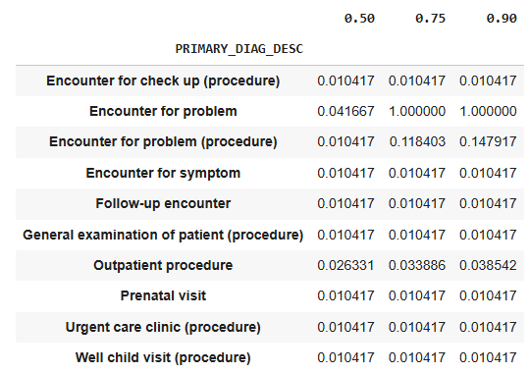
The Brad-Days per encounter analysis shows that the capacity consumption in the service lines is significantly uneven. The bed-day utilisation on inpatient encounters is significantly higher than any other type of service. This suggests that, inpatient encounters may have a smaller proportion of the total encounter volume, but control much capacity use because the LOS is much longer on this group. Conversely, the bed-days per encounter of ambulatory, outpatient, emergency, urgent care, wellness encounters are very low due to their shortness and small resource intensity. This observation highlights a very important operating difference between the volume of encounter and the burden of capacity. The ambulatory or outpatient care services are of relatively low volume, resulting in minimal bed occupancy, and are in contrast to the inpatient services, which create a long-lasting pressure on bed occupancy. The same tendencies are also frequently reported in the field of healthcare operations research, where inpatient LOS is found to be one of the main causes of bed congestion and sluggish flow of patients (Lee et al., 2024). Capacity planning Compared to the outpatient encounter or emergency volume reduction; this hints that efficiency gains in the inpatient pathways will have significantly larger returns.
Diagnosis-Level Intensity and LOS Distribution
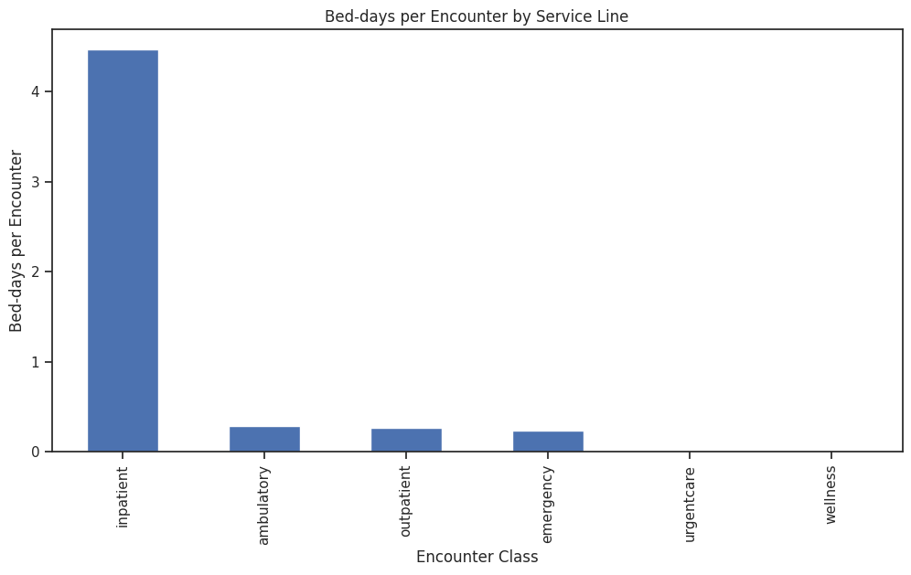
Analysis at the diagnosis level further brings out heterogeneity in the impact of capacity. LOS metrics expressed in percentiles indicate that a number of categories of diagnosis are typified by repeatedly brief stays in the median (50 th percentile), upper quartile (75 th percentile) and upper tail (90 th percentile). Brackets like frequent check-ups and examinations, antenatal check-ups, urgent care check-ups and well-child check-ups have consistently low values of LOS and this is a characteristic of predictable and low intensity utilisation. The category, on the contrary, Encounter for problem, has a strongly different profile. Although the median LOS is quite low, the higher percentiles grow significantly, and the 75 th and the 90 th percentiles are much higher. Such a skewed distribution implies that the disproportionately long stays are explained by a group of encounters within this category. These types of right-skewed LOS distributions can be typical of heterogeneous clinical populations in which few complicated cases can contribute a big portion of bed utilisation (Maynou et al., 2023). In the same way, the encounter for problem (procedure) exhibits high LOS values in the high percentiles compared to their median, and hence episodic, though clinically significant, affected capacity. These results imply that the classification of diagnoses related to problem-based care brings variability and uncertainty to capacity demand even where the average LOS may seem to be low.
Implications for Sustained Capacity Pressure
Even when this analysis is not explicitly modeling temporal growth pathways of each diagnosis, the observed distributions of LOS do shed valuable light on the sustained capacity pressure. Groups of diagnosis with high upper-tail LOS values have the higher likelihood of creating bottlenecks over a prolonged period, especially when the volumes of encounter are growing as time goes by. Previous research has indicated that even the slight increase of such high-intensity categories may cause nonlinear growth in bed occupancy and system congestion (Seo et al., 2024). Operational implications of these findings include the capacity management strategies should be based on the diagnosis categories that have high LOS variability instead of the total number of encounters only. Early clinical review, focused discharge planning, and the use of pathway standardisation of problem-based encounters are some of the interventions that could be used to reduce extreme LOS values and enhance overall system efficiency. Notably, the strategies are consistent with the evidence that LOS variability, as opposed to the mean LOS per se, is one of the determinants of hospital throughput and resilience (Lee et al., 2024).

4.3 Seasonal Sensitivity of Clinical Demand
In this part, the seasonal change in hospital utilisation at the diagnosis level, and seek to find clinical categories that were especially sensitive to certain time was carriedout. Instead of looking at the gross volumes of utilisation, seasonality is evaluated on a normalised length-of-stay (LOS) model that can allow meaningful comparisons across diagnoses with varied baseline levels of utilisation.
Diagnosis-Level Seasonal Sensitivity
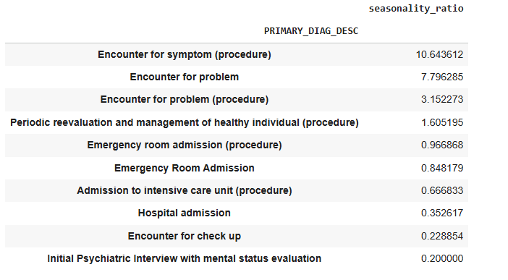
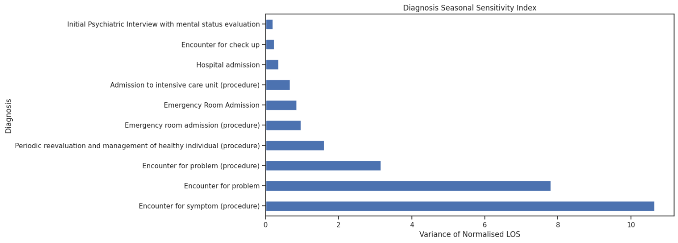
The seasonality sensitivity index which is the variance in the normalised LOS among months shows a great heterogeneity in seasonality responsiveness across diagnosis groups. Several distinct categories of diagnoses have significantly high seasonal variability, meaning that they are very sensitive to certain times of the year. Specifically, the seasonal sensitivity of the symptom (procedure) encounter is the largest, and the next ones are that of problem and problem (procedure) encounter. These groups have strong variations in LOS compared to their baseline levels, which indicates a period-based increase in the intensity of care within specific months. These patterns have shown that these diagnoses are not uniformly spread throughout the calendar year but rather have concentrated periods of high levels of utilisation. These spikes could be seasonal distribution of the disease, environmental exposures, or the deferred care, which accumulates and occurs during a particular period. The previous studies have indicated that symptom based and problem based encounters are particularly vulnerable to seasonal conditions, such as temperature change as well as cycles of infectious diseases, which may cause disproportionate use of the healthcare systems (PoshtMashhadi et al., 2025). Conversely, some of the diagnoses present low amounts of seasonal sensitivity. The groups, like Hospital admission, Admission to intensive care unit (procedure), Encounter with check-up, and the first psychiatric meeting with mental status assessment have a little difference in normalised LOS across months. This consistency indicates that the diagnosis of the diagnoses to a great extent is not dependent on seasonal influences and rather determined by an underlying clinical necessity. The same has been observed in the literature, in which high-acuity inpatient and psychiatric services are quite stable in demand over the year (Maynou et al., 2023).
Operational Implications of Seasonal Sensitivity
The difference in the trends of seasonally sensitive and seasonally stable diagnosis has serious consequences on capacity planning. Such diagnoses where there is a high seasonal sensitivity are predictable drivers of temporal pressure that are predictable and can be managed proactively. As an example, short-term increases in workforce or specific bed placements, or increased outpatient options in high-months can reduce capacity pressures in these categories. On the other hand, diagnoses with low seasonal variability require the availability of the resources at all times regardless of the season. This highlights the significance of maintaining baseline inpatient and intensive care capacity at times of low aggregate demand. Using aggregate seasonal trends with no granularity on diagnosis level can easily blur important planning requirements and is likely to lead to either under-allocation or over-allocation of resources. Notably, the use of normalised length-of-stay variance makes it possible to establish the sensitivity to seasonal variations regardless of the frequency of diagnoses. The methodology also helps reduce biases of diagnosing high volumes and makes variability reflect actual temporal variability and not scale effects. Recent healthcare analytics studies have proposed such normalisation as a more accurate method of identifying seasonality in heterogeneous clinical populations (Seo et al., 2024).

4.4 Patient Flow and Repeat Utilisation Dynamics
The part measures patient journey patterns using multiple encounters, specifically, repeat utilisation, short-interval return, and inter-service line transition. Instead of concentrating on binary 30-day readmission measures, the analysis adopts time-to-next-encounter design to develop more broad healthcare re-engagement and maintenance of care patterns.
Time-to-Next-Encounter Patterns
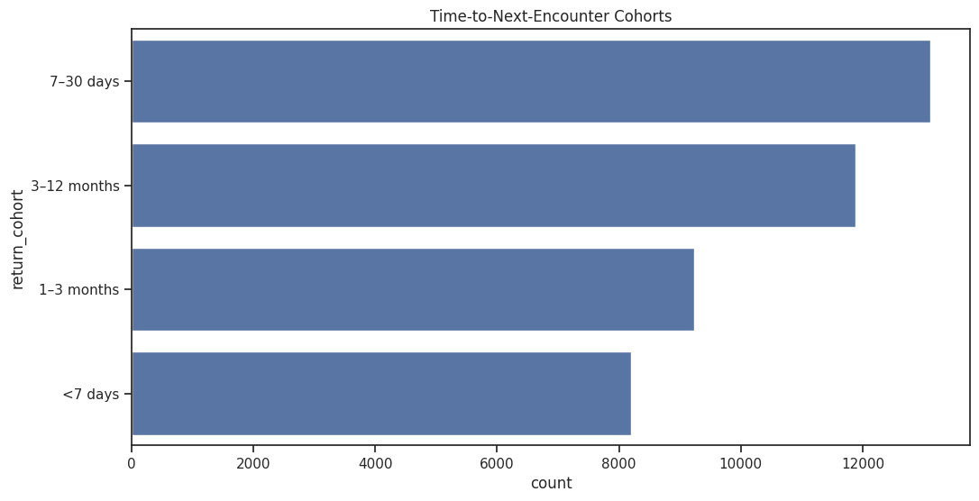
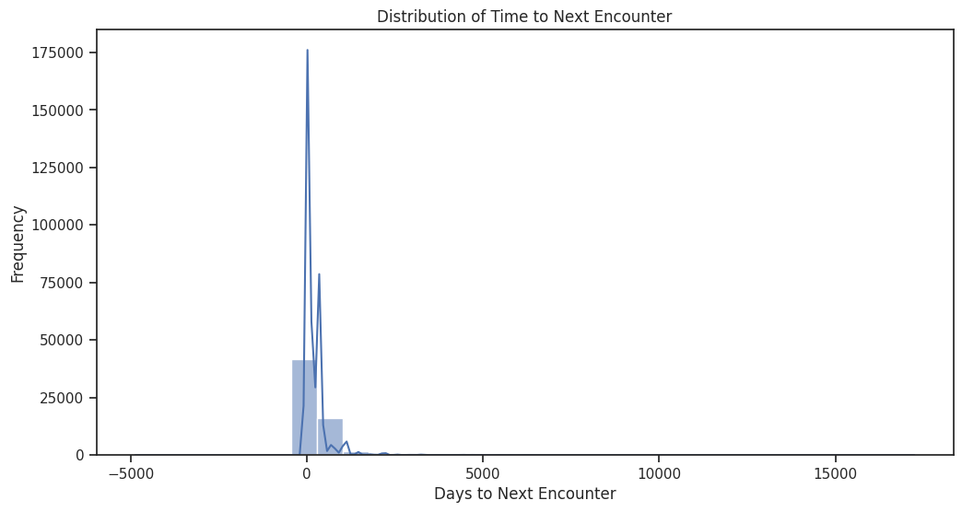
The skewness of the number of days to the next encounter is strongly right-skewed as there is a large number of patients who come back to the healthcare system within a comparatively short span of time. The study of cohort shows that the greatest percentage of patients re-engage in the range of 7-30-days and the ranges 3-12 months and 1-3 months. The presence of the <7 day cohort though in smaller proportion of the overall returns is operationally significant because of its linkage to acute follow-up requirements and discharge inefficiency. These results show that repeat utilisation is not limited to short timeframes of post-discharge but spreads across different time horizons. Previous studies have also indicated that recurring short-term readmission is usually an indication of unattended clinical concerns, the lack of outpatient follow-up, or even social determinants of health hindering recuperation instead of inpatient care failure (Turbow et al., 2024). The significance of the 730day cohort indicates that the 730day interval is a sensitive period of time in which intervention can be targeted.
Implications for 30-Day Readmissions
Although conventional performance indicators commonly focus on 30-day readmission rates, as the observed distribution shows, a significant portion of returns among patients takes place slightly outside of the immediate post-discharge period. This restriction of the limited readmission metrics might result in underestimating continued system interaction and demand of resources. The broader application of the analysis lens on wider areas of patient returns allows a more detailed view of patient flow and possible healthcare dependency, which is in line with recent critiques of readmission-based assessment frameworks (Maynou et al., 2023).

5. Discussion and Insights
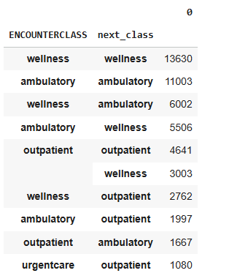
Encounter class transition analysis shows high persistence of service lines, especially wellness-to-wellness, and ambulatory-to-ambulatory ones. These dominant patterns indicate managed, planned patterns of care, like routine checkups or chronic illnesses. Nevertheless, there are also significant cross-service flows, in particular, between wellness and ambulatory care, ambulatory and outpatient services. Such cross-service movements point to fluid patient flows as opposed to linearity in the course of the care system. Although these transitions can be a sign of proper escalation or de-escalation of care, it can also indicate the discontinuity or the lack of needs that trigger repeated use of the service. This situation has been also reported in healthcare systems with fragmented care coordination that has facilitated repeat encounters and inefficiencies (Lee et al., 2024). Urgent care to outpatient transition, albeit with a lower frequency, are especially relevant regarding the planning perspective. The sequences can reflect the postponed definitive care or inadequate access to timely follow-up, which makes the number of system touchpoints with a single episode of care many. Determining and optimising these transition points is an opportunity to decrease the unnecessary utilisation and enhance patient experience.
Operational and Planning Implications
The existing evidence on both time-to-return cohort and analysis of pathway transitions indicates that repeat utilisation are influenced by short-run and medium-run dynamics. Interventions that only target the prevention of immediate readmissions are thus not likely to have the entire patient flow pressure covered. Rather, more specific approaches (including, but not limited to) improved discharge planning, early outpatient follow-up with 7-30 days, and better care coordination between ambulatory and outpatient care can produce a larger effect. In terms of capacity-planning, a better forecasting of demand has been made possible through the identification of predictable patterns of returns beyond the first admissions. The integration of patient journey analytics into operational dashboards may help assist in staffing, schedule, and resource placement decisions. Recent reports focus on the fact that pathway-based analytics give a set of actionable insights into the optimisation of the system level rather than encounter-level metrics alone (Seo et al., 2024).

6. Limitations
Although the present research is able to provide valuable understanding of the hospital utilisation, capacity efficiency and patient flow, a number of limitations should be noted during interpretation of the findings. To begin with, the analysis is grounded on artificial healthcare data which was created with the help of the Synthea framework. Even though Synthea is popular to perform research and education and is developed to reflect realistic healthcare patterns, synthetics data might not be comprehensive enough to reflect the complexity, variability, and institutional differences of real-world hospital systems (Walonoski et al., 2018). As a result, the level of absolute utilisation and diagnosis prevalence must be viewed as exemplary, not representative of a particular healthcare organisation. Second, the dataset includes mixed heterogeneous data which covers inpatient, outpatient, ambulatory, wellness, and urgent care visits. Although the normalisation and stratification of the utilisation measures, especially percentile-based LOS measurements and the normalised seasonality indices, were taken in an analytical manner, there might be remaining levels of heterogeneity affecting the aggregate patterns. Moreover, some clinical categories comprise broad diagnostic groups, where it is difficult to distinguish clinically different subpopulations with different care paths or risk factors. Third, the analysis is mainly based on the exploratory and descriptive approaches. Although this method is appropriate in the determination of trends, aberrations and indicator of operations, it fails to provide causal connections. Noted admissions, bed-days or repeat utilisation spikes can be indicative of unknown variables like policy changes, external shocks or population health dynamics. According to the recent healthcare analytics literature, EDA is supposed to be regarded as the source of hypothesis formulation, but not a source of conclusive inferences (Seo et al., 2024).

7. Ethical Considerations
Ethically, the use of synthetic data significantly reduces patient privacy, confidentiality and data protection risks. There is no personal information that may be identified and the analysis does not violate the principles of data protection laws like GDPR. However, the issue of privacy is not the only point of ethical responsibility. The results of the analysis can be used to make operational or policy decisions; hence, caution should be taken against overgeneralisation or misinterpretation of the results. It is necessary to report assumptions, limitations, and uncertainty in a transparent manner to be able to use data-driven wisdom in the healthcare decision-making process responsibly (Maynou et al., 2023).

8. Conclusion
In this portfolio, there was an organised exploratory data analysis framework that was used to meet the encounter level of healthcare data to study the dynamics of utilisation, capacity efficiency, seasonal sensitivity and patient flow patterns within a hospital network. The research offers an overall viewpoint of the operation of healthcare demand and the manner in which the capacity is used up across services and diagnoses by incorporating a temporal aggregation, sound statistical indicators, and a pathway-based analysis. These results indicate that there is long-term expansion and episodic fluctuation that influence hospital utilisation. Monthly and quarterly analyses have demonstrated that there are continued admissions growths and statistically significant demand bursts, which are concurrent with high emergency activity and disproportional bed-day utilisation. Capacity efficiency analysis showed that the inpatient services accounted for much of the bed occupancy in terms of lower encounter volumes, whereas the diagnosis-level LOS distributions showed that a few clinical categories pressure capacity disproportionately. The seasonal analysis also indicated that the sensitivity of demand is diagnosis specific whereby symptom and problem based encounters show high levels of temporal variation compared to more consistent inpatient and intensive care services. The analysis of the patient journey further expanded the assessment beyond single interactions indicating that returns and complicated service-line transitions are common in the short and middle run. Such trends suggest that continuity-of-care processes lead to the increased use of healthcare, as opposed to single admissions, and these metrics validate the shortcomings of the state of readmission-centered performance measures. Taken together, these observations prove the usefulness of exploratory analytics in aiding the capacity planning process, discharge optimisation, and specific follow-up plans. This paper demonstrates how data-driven solutions can be used to improve the resilience of operations and guide evidence-based healthcare management by changing the analytical perspective on variability and efficiency, as well as on volume, to improve operational resilience. This analysis can be further expanded on in future work by predictive modelling and incorporating external factors of the population that will be used in the future to further enhance planning and decision support.

9. References
DeAngelo, S. (2025) Predictors and Trends of 30-day Readmissions in Patients With Acute HFpEF, PMC, 2025. Available at: https://www.ncbi.nlm.nih.gov/pmc/articles/PMC11791174/ (Accessed: date).
Eriten, S. (2025) Retrospective analysis of admissions to the Emergency Department of an urban state hospital: A cross-sectional study of 5,279,630 patient visits (2019–2024), Medicine (Baltimore). doi:10.1097/MD.0000000000041669.
Lee, H. et al. (2024) Hospital Length of Stay Prediction for Planned Admissions Using Machine Learning, Journal of Medical Internet Research, 26, e59260.
Maynou, L. et al. (2023) Factors associated with longer wait times, admission and emergency department outcomes, Emergency Medicine Journal, 40(4), pp.248–254.
PoshtMashhadi, A. et al. (2025) A systematic review of heatwaves, cold waves, and daily temperature variation on emergency department admissions, Science of the Total Environment.
Seo, H. et al. (2024) Forecasting Hospital Room and Ward Occupancy Using Time-Series Models, JMIR Medical Informatics, 12, e53400.
Turbow, S. et al. (2024) Characteristics of 30-Day All-Cause Hospital Readmissions, 2016–2020, BMC Health Services Research.

